TITLE: TIMES NEW ROMAN 14 BOLD (CAPITALS)

First Author,¹ Second Author,² and Corresponding Author^{1,}*

¹ Department, Institution, Street Name, City, Zip Code, Country.
² Department, Institution, Street Name, City, Zip Code, Country.
*E-mail: corresponding@author.jp

ABSTRACT
The whole document has to be typed in ‘Times New Roman’ with 1.5 line spacing: the title in 14 pt bold CAPITALS, the author names in 12 pt, the affiliation addresses in 11 pt, and the abstract text in 12 pt. The title, the author names, the affiliation addresses, and the abstract text should be separated with single blank lines. If references need to be cited, reference numbers should be put into square brackets [1]. Figures and captions should be centered (Fig. 1).
The first line of each paragraph should be indented by five spaces. All abstracts, not exceeding 1 page in total length on A4 paper, can be submitted only by email to blcorganizer@toyotariken.jp before October 1, 2015.

References
[1] T. N. Roman12pt, A. Bcd, and E. Fgh, J. Name. 123, 456 (2015).

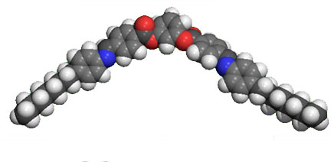
Figure 1. Figure captions in 12 pt.

Deadline October 1, 2015

